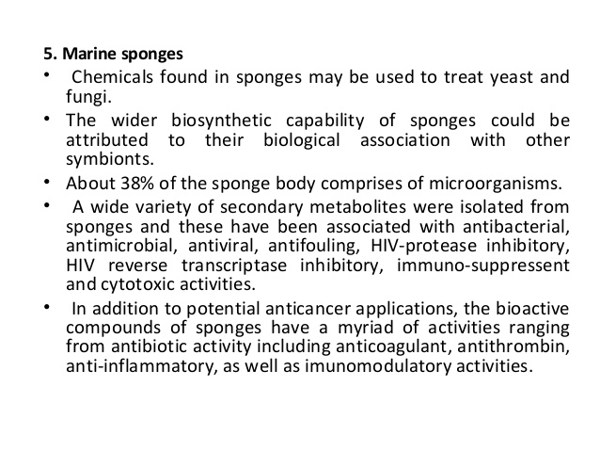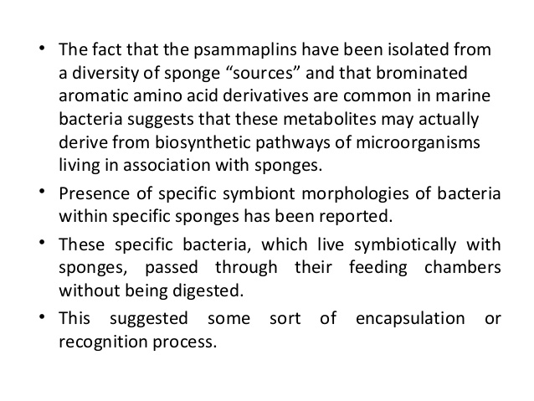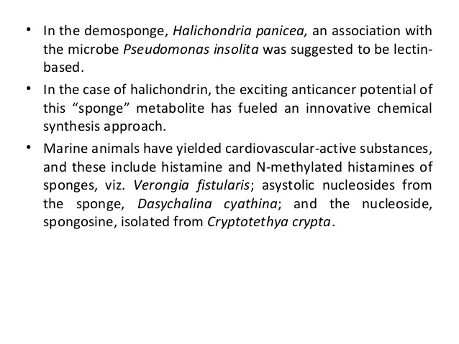

PORIFERA TAXONOMIC POSITION

Sponges were considered as plants because of their sedentary life for a long time. Ellis in 1765 placed them in Animal Kingdom. Linnaeus placed porifera in zoophyta. In 1836 Robert Grant coined the word Porifera' and sponges are placed in it. Sponges are a group of multicellular, cellular grade organisms. They are the lowest metazoan group. The following are the Phylum porifera characters.
- Sponges are multi cellular, sedentary animals.
- They are cellular grade metazoans.
- Spongesare diplo-blastic organisms.
- Their body shows a number of openings called dermal ostia Hence this group is called Phylum Porifera.
- In the centre of the body paragastric cavity is present. It opens out through osculum.
- Skeleton is made by spicules.The classification of phylum porifera based on spicules.
- In the body of porifera canal system is seen.
- Flagellated cells or choanocytes are present. They catch the food particles of the incurrent water.
- Digestive, respiratory and circulatory systems are absent.
- Asexual reproduction is by budding, gemmule formation etc.
- Sexual reproduction is by union of male and female gametes.
PORIFERA – AFFINITIES WITH COELENTERATE

a) PORIFERA – RESEMBLANCES WITH COELENTERATE:
- Both show diploblastic body.
- Presence of Mesoglea.
- Both are fixed animals.
- Presence of central cavity in the body.
- Presence of asexual reproduction by budding.
- Presence of free swimming larva in both groups.
b) PORIFERA – DIFFERENCES WITH COELENTERATE:
- Absence of tissues in porifera.
- Absence of organs and systems in porifera.
- Absence of stinging cells in porifera.
- Absence of nervous system in porifera.
- Presence of intracellular digestion in porifera.
- Presence of flagellated cells in porifera.

PORIFERA –AFFINITIES WITH PHYLUM PROTOZOA

a) PORIFERA – RESEMBLANCES WITH PROTOZOA:
- Sponges resemble a colonial protozoan called 'Proterospongia' in the following characters.
- Presence of collar cell in both.
- Presence of amoeboid cells in both.
PORIFERA – DIFFERENCES WITH PROTOZOA :
- Canal system is present in sponges.
- Presence of skeleton in sponges.
- Presence of Ostia and Oscula in sponges.
- Presence of division of labour among the cells of sponges.
The origin of sponges is not clearly understood. Porifera resembles with Proterospongia (Protozoa) and coelenterates. The resemblence is only superficial. The presence of choanocytes in the body of sponges has led some workers to believe that they are originated from colonial protozoans. But this view is not correct. The flagellated cells are to the outside in Proterospongia, but in sponges the flagellated cells are internal.

Hence it is supposed that sponges might have originated from some different group of flagellates and evolved separately or they have separated themselves from the metazoan stalk at an early period of their evolution.

Hence this group is a blind off shoot of the main line of organic evolution.

Considerin the above facts Robert Grant separated sponges and kept them in phylum porifera.

